PT8616 GPS Genlock option for

PT5300 HD SD Varitime TM Sync Generator

The PT8616 option should only be installed by technical qualified personnel.
For the PT5300 Sync Generator to support the PT8616 option, it must be verified that the PT5300 Sync generator has master software 5.4 – 3.2 installed.
The version of the master software can be identified during power up of the Sync generator. Immediately after the self-test the display shows ”Version: xx.x-yy.y”, where xx.x indicates the master processor software version and the yy.y indicates the internal sync pulse generator software version.

Packing list:
- Hexagonal spacer 16 mm 4008 107 27480 8
- Hexagonal spacer 9 mm 4008 107 27470 8
- Washer Brass 2522 600 10018 16
- Pan Head Screw M3x4 2522 178 31050 8
- Ribbon Cable with micro 20 pole connectors 4008 105 04030 1
- PT8616 GPS Genlock Module 9449 086 16001 1
- PT8616 Optionplate 1
- XLR cable assembly 4008 105 04880 1 *
- BNC cable assembly 4008 105 04440 1 *
- Nut for BNC connector 2422 034 17419 1 *
- Lockwasher for BNC connector 2422 034 17421 1 *

*) Item 8, 9, 10 and 11 is only supplied if the PT8616 is ordered without the PT8620 LTC Option.
Installation procedure for PT8616 module:
- Open the Sync generator by removing the top cover.
- Locate connector XE1 on the main board (second slot, as displayed on picture 1)
- The slot may be occupied by a PT8606 option. In that case, remove this module.
- If no PT8620 LTC module is installed, make sure that there are no BNC cap in the ”in” hole on the backpanel of the PT5300.
- When options are mounted in the lower level, remove the screws. Mount the eight 16 mm spacers and the eight 9 mm spacers instead. When no options are installed in the lower level, mount the 16 washers underneath the spacers (2 washers for each spacer).
- If no PT8620 LTC module is installed, install the BNC cable assembly to the MCX connector marked ”CON3” on the PT8616 module.
- Install the PT8616 GPS Genlock module (with connectors being on top).
- If no PT8620 LTC module is installed, mount the BNC lockwasher and the nut on the BNC connector.
- Mount the eight screws.

Installation procedure for LTC output connectors:
- If the PT5300 has a PT8620 LTC module installed you must skip step 2 to 6 and go directly to step 7.
- There are two LTC outputs, named LTC A and LTC B. One is available via XLR and one via BNC.
- Mount the XLR connector in the leftmost XLR slot. If other options are occupying the XLR slot, either remove the occupying XLR connector or leave the LTC unavailable via XLR.
- Mount the 3 pole connector in the other end of the XLR cable assembly to LTC A on the PT8616 module in the connector marked ”J4”.
- Mount the BNC connector in an available slot in the PT5300 backpanel.
- Mount the BNC lockwasher and nut.
- Mount the ribboncable from the PT8616 module to the PT5300 mainboard.
- Mount the top cover on the PT5300.
- Place new option type plate on the side of the generator in order to make later identification possible.
- The option is now installed. Perform a factory reset on the PT5300 to setup the PT8616 option. This is done, by powering up the PT5300 while pressing and holding the LEFT and RIGHT buttons down simultaneously.

Picture 1:
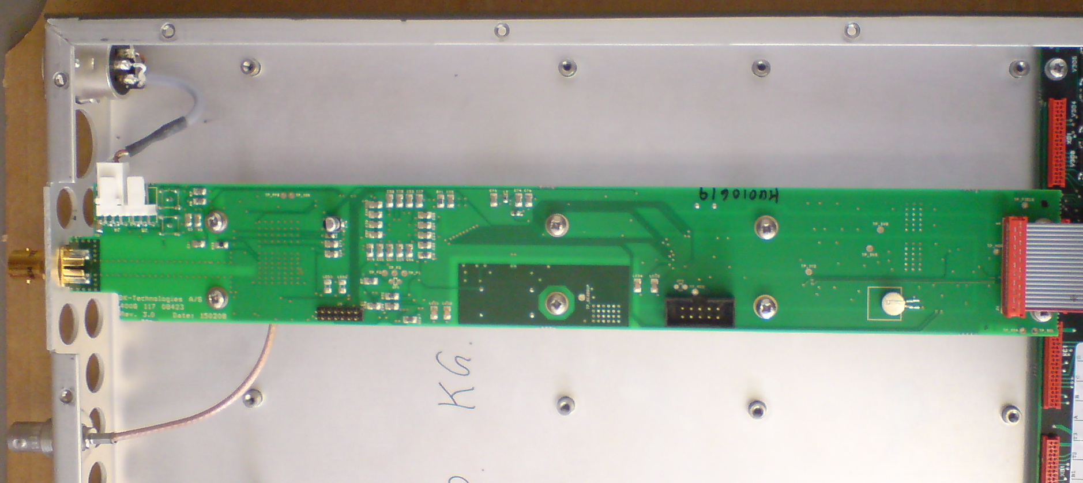
Picture 1: The positioning of the PT8616 GPS Genlock module in the PT5300.

